Day 01 –
9, 1480, 1108, 1662, 2235

Problem: 2235

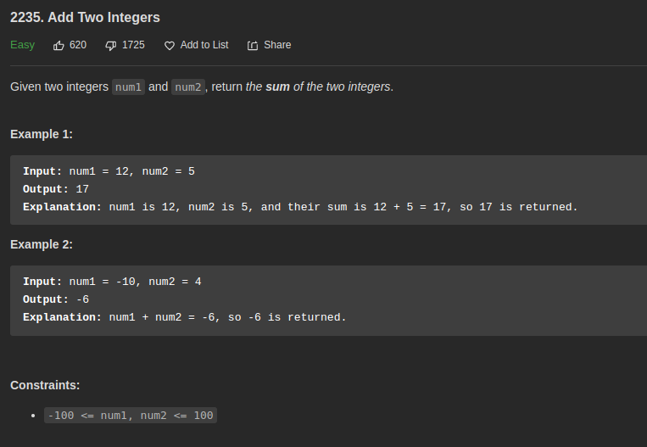

Solution:

package O1_easy;

public class O1_AddTwoIntegers_2235 {
public static void main(String[] args) {
Solution s = new Solution();
System.out.println(s.sum(5,8));
}
}

class Solution {
public int sum(int num1, int num2) {
return num1+num2;
}
}

// https://leetcode.com/problems/add-two-integers/

Others solution:

class Solution {
public int sum(int num1, int num2) {
if(num2 == 0) return num1;
int temp = (num1 & num2) << 1;
return sum(num1 ^ num2,temp);
}
}

Problem: 09

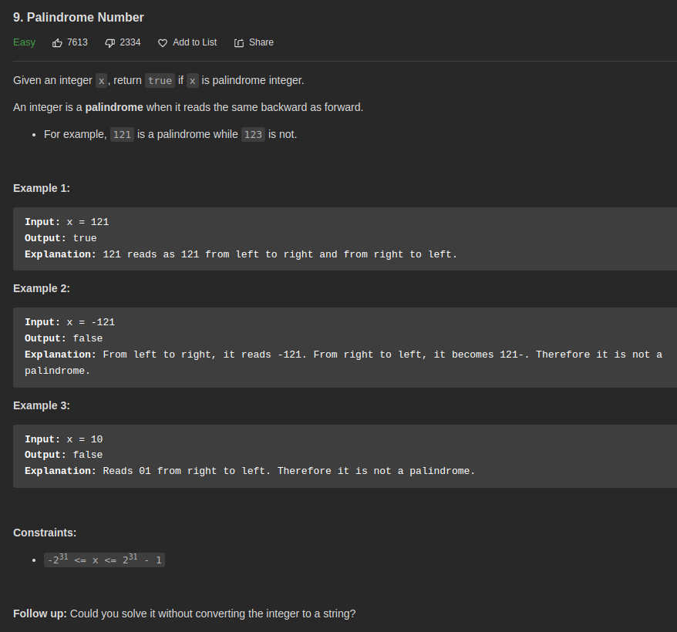

Solution:

package O1_easy;

public class O2_Palindrome_9 {
public static void main(String args[]){
Solution_9 solution = new Solution_9();
System.out.println(solution.isPalindrome(121));
System.out.println(solution.isPalindrome(123));
}
}

class Solution_9 {
public boolean isPalindrome(int x) {
String s = String.valueOf(x);
StringBuffer sb = new StringBuffer(s);
String s1 = String.valueOf(sb.reverse());

if (s.equals(s1)){
return true;
}else {
return false;
}
}
}

// https://leetcode.com/problems/palindrome-number/

Another Solution:
public class Solution {
public boolean isPalindrome(int x) {
if(x < 0) return false;
int y = x;
int res = 0;
while(y != 0) {
res = res * 10 + y % 10;
y /= 10;
}
return x == res;
}
}

Another Solution:
public boolean isPalindrome(int x) {
int p = x, q = 0;
while (p >= 1) {
q *= 10;
q += p % 10;
p /= 10;
}
return q == x;
}

Problem: 1480

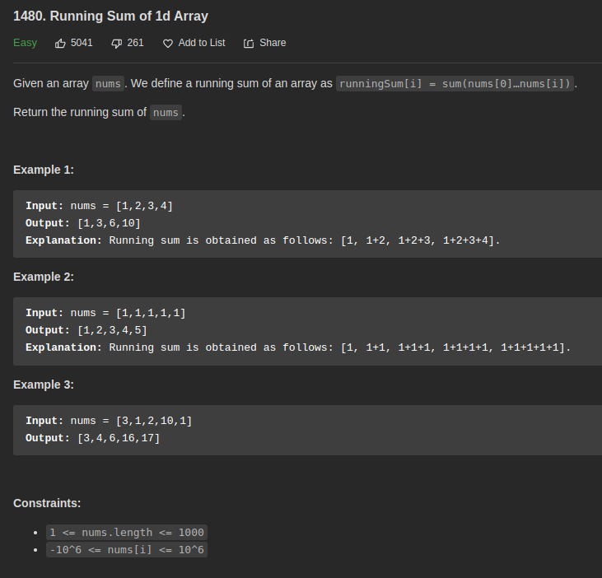

Solution:

package O1_easy;

import java.util.Arrays;

public class O3_RunningSum1dArray_1480 {
public static void main(String[] args) {
Solution_1480 solution_1480 = new Solution_1480();
int[] nums = {1,1,1,1,1};
System.out.println(Arrays.toString(solution_1480.runningSum(nums)));
int[] nums2 = {1,2,3,4};
System.out.println(Arrays.toString(solution_1480.runningSum(nums2)));
}
}
class Solution_1480 {
public int[] runningSum(int[] nums) {
int[] result = new int[nums.length];
int sum = 0;
for (int i=0; i < nums.length; i++){
sum = sum + nums[i];
result[i] = sum;
}
return result;
}
}

/**
* {1, 2, 3, 4}
*
* Iteration: 1
* sum = sum + num[i] | sum = 0 + 1 = 1
* result[i] = sum | result[0] = 1
*
* Iteration: 2
* sum = 1 + 2 = 3 , result[1] = 3
*
* Iteration: 3
* sum = 3 + 3 = 6 , result[2] = 6
*
* Iteration: 4
* sum = 3 + 6 = 10 , result[3] = 10
*/

// https://leetcode.com/problems/running-sum-of-1d-array/

Another solution

public int[] runningSum(int[] nums) {
// modify the input array, adding n[i] with n[i-1]
for(int i = 1; i < nums.length; i++) {
nums[i] += nums[i-1];
}

// return the modified array
return nums;
}

Another solution

class Solution {
public int[] runningSum(int[] nums) {
return IntStream.range(0,nums.length).map(i->i==0?nums[i]:(nums[i]+=nums[i-1])).toArray();
}
}

Problem: 1662

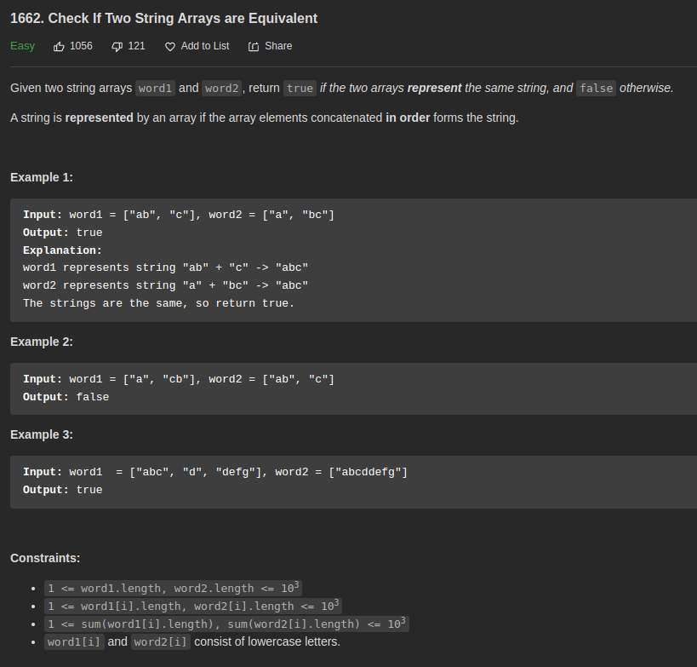
Solution:

package O1_easy;

public class O4_StringEquivalent_1662 {
public static void main(String[] args) {
Solution_1662 solution_1662 = new Solution_1662();
String[] word1 = {"a", "cb"};
String[] word2 = {"ab", "c"};
System.out.println(solution_1662.arrayStringsAreEqual(word1, word2));
}
}
class Solution_1662 {
public boolean arrayStringsAreEqual(String[] word1, String[] word2) {
String r1 = "";
for (int i = 0; i<word1.length ; i++){
r1 += word1[i];
}
System.out.println(r1);
String r2 = "";
for (int i = 0; i<word2.length ; i++){
r2 += word2[i];
}
System.out.println(r2);

if (r1.equals(r2)){
return true;
}else {
return false;
}
}
}

// https://leetcode.com/problems/check-if-two-string-arrays-are-equivalent/

Another Solution:
class Solution {
public boolean arrayStringsAreEqual(String[] word1, String[] word2) {
return String.join("", word1).equals(String.join("", word2));
}
}

class Solution {
public boolean arrayStringsAreEqual(String[] word1, String[] word2) {
StringBuilder sb1 = new StringBuilder(), sb2 = new StringBuilder();
for(String word: word1)
sb1.append(word);

for(String word: word2)
sb2.append(word);

return sb1.toString().equals(sb2.toString());
}
}

Another Solution:
class Solution {
public boolean arrayStringsAreEqual(String[] word1, String[] word2) {
int idx1 = 0, idx2 = 0, arrIdx1 = 0, arrIdx2 = 0;
while (arrIdx1 < word1.length && arrIdx2 < word2.length) {
if (word1[arrIdx1].charAt(idx1) != word2[arrIdx2].charAt(idx2)) return false;
if (idx1 == word1[arrIdx1].length() - 1) {
idx1 = 0;
arrIdx1++;
} else idx1++;
if (idx2 == word2[arrIdx2].length() - 1) {
idx2 = 0;
arrIdx2++;
} else idx2++;
}
return arrIdx1 == word1.length && arrIdx2 == word2.length;
}
}

Same but shorter:
class Solution {
public boolean arrayStringsAreEqual(String[] word1, String[] word2) {
int idx1 = 0, idx2 = 0, arrIdx1 = 0, arrIdx2 = 0;
while (arrIdx1 < word1.length && arrIdx2 < word2.length) {
if (word1[arrIdx1].charAt(idx1) != word2[arrIdx2].charAt(idx2)) return false;
idx1 = (++idx1) % word1[arrIdx1].length();
idx2 = (++idx2) % word2[arrIdx2].length();
if (idx1 == 0) arrIdx1++;
if (idx2 == 0) arrIdx2++;
}
return arrIdx1 == word1.length && arrIdx2 == word2.length;
}
}

Problem: 1108

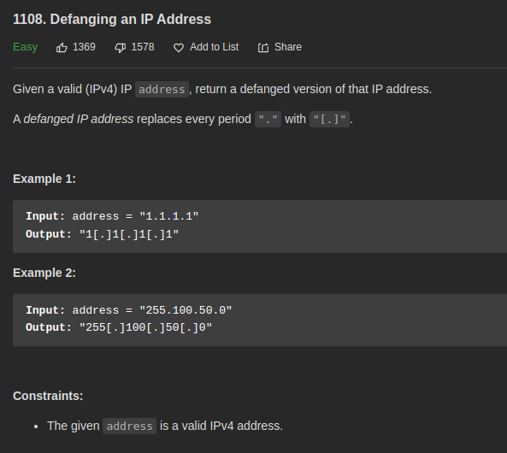

Solution:

package O1_easy;

public class O5_DefiningIpAddress_1108 {
public static void main(String[] args) {
Solution_1108 solution_1108 = new Solution_1108();
System.out.println(solution_1108.defangIPaddr("1.1.1.1"));
}
}
class Solution_1108 {
public String defangIPaddr(String address) {
return address.replace(".", "[.]");
}
}

Another solution:
class Solution {
public String defangIPaddr(String address) {
StringBuilder str = new StringBuilder();
for (int i = 0; i < address.length(); i++){
if (address.charAt(i) == '.'){
str.append("[.]");
} else {
str.append(address.charAt(i));
}
}
return str.toString();
}
}

Another Solution:
public String defangIPaddr(String address) {
return address.replaceAll("\\.", "[.]");
}

Day 02
Problem:

Solution:

Problem:

Solution:

Problem:

Solution:

Problem:

Solution:

Problem:

Solution:

Day 03
Problem:

Solution:

Problem:

Solution:

Problem:

Solution:

Problem:

Solution:

Problem:

Solution:

